Service shown only for assistant deans only:

The procedure to show the bellow links is “PORTAL1.DISPLAY_ACADEMIC_LINK5”

as

server_name varchar2(256) := portal.wwctx_api.get_server_name;

server_protocol varchar2(10) := portal.wwctx_api.get_server_protocol;

param_emp_code varchar2(10) := portal1.get_user_empno(portal.wwctx_api.get_user());

common_link varchar2(250):= server_protocol||'://'||server_name||'/portal/page/portal/SQUPortal_Faculty_Page_Group/';

student_status_title varchar2(250);

course_list_old_title varchar2(250);

course_list_new_title varchar2(250);

timetable_title varchar2(250);

exam_timetable_title varchar2(250);

survey_summary_title varchar2(250);

publication_title1 varchar2(250);

publication_title2 varchar2(250);

teaching_survey_rep_title varchar2(250);

teaching_survey_stat_title varchar2(250);

prizes_title varchar2(250);

access_survey_rep char(1) :='N';

access_survey_chart char(1) :='N';

publication_download_msg1 varchar2(200);

publication_download_msg2 varchar2(50);

publication_download_msg3 varchar2(10);

publication_download_msg4 varchar2(50);

publication_download_msg5 varchar2(200);

publication_path1 varchar2(250):= server_protocol||'://'||server_name||'/portal/page/portal/Documentation/RMS/ierms.zip';

publication_path2 varchar2(250):= server_protocol||'://'||server_name||'/portal/page/portal/Documentation/RMS/';

course_attend_title varchar2(250);

access_course_attend char(1):='N';

assistant_course_list_title varchar2(250);

lang varchar2(10);

course_list_msg varchar2(50);

course_software_title varchar2(250);

begin

begin

select teaching_survey.ACCESS_TEACHING_SURVEY_REP(param_emp_code),

teaching_survey.ACCESS_ALL_SURVEYS(param_emp_code)

into access_survey_rep , access_survey_chart

from dual;

exception

when no_data_found then

access_survey_rep:= 'N';

when others then

access_survey_rep:= 'N';

end;

begin

select SISPORTAL.access_course_attendance(param_emp_code)

into access_course_attend

from dual;

exception

when no_data_found then

access_course_attend:= 'N';

when others then

access_course_attend:= 'N';

end;

if (substr(portal.wwctx_api.get_http_language,1,2) = 'ar' ) then

student_status_title := 'حالة الطالب';

course_list_msg :='بحله جديده';

course_list_new_title := 'المواد التدريسية والطلاب المسجلين';

course_list_old_title := 'المواد التدريسية والطلاب المسجلين';

timetable_title := 'الجدول الدراسي';

exam_timetable_title := 'جدول الامتحانات';

survey_summary_title := 'ملخص استبانة مقرر دراسي وطرق تدريسه';

teaching_survey_rep_title :='تقرير نتائج استبانات تقييم المقررات الدراسية وطرق تدريسه';

teaching_survey_stat_title:='احصائيات استبانات تقييم المقررات الدراسية وطرق تدريسه';

prizes_title := 'الجوائز العلمية والأكاديمية';

publication_title1 := 'المنشورات العلمية';

publication_title2 :=' (نظام إدارة البحوث)';

publication_download_msg1 := '( للدخول لنظام المنشورات العلمية الرجاء اضافة "squ" قبل اسم المستخدم. مثال: "squ\user1") ';

assistant_course_list_title :='قائمة المقرارات في الكلية';

lang :='AR-OM';

course_software_title := 'الاحتياجات من البرامج التعليمية للمقررات الدراسية';

course_attend_title := 'تسجيل حضور الطلاب للمقررات الدراسية';

else

student_status_title := 'Student Status';

course_list_msg :='new version';

course_list_new_title := 'Courses and Students List';

course_list_old_title := 'Courses and Students List';

timetable_title := 'Timetable';

exam_timetable_title := 'Exam Timetable';

survey_summary_title :='Course and Teaching Survey Summary';

teaching_survey_rep_title := 'Course and Teaching Survey Report';

teaching_survey_stat_title:='Course and Teaching Survey Statistics';

prizes_title := 'Prizes';

publication_title1 := 'Publications';

publication_title2 :=' (Research management system)';

publication_download_msg1 := '(To access publication, please add "squ" before username, eg. "squ\user1")';

assistant_course_list_title :='List of College courses';

lang :='EN-US';

course_software_title := 'Required Teaching Software for courses';

course_attend_title := 'Student Course Attendance';

end if;

htp.p('<ul>');

htp.p('<li><a href="'||common_link||'StudentStatusPage" target="_blank">'||student_status_title||'</a> </li>');

htp.p('<li><a href="'||common_link||'CourseClassList2" target="_blank" >'||course_list_new_title||'</a> ('|| course_list_msg

||')</li>');

htp.p('<li><a href="'||common_link||'CourseList" target="_blank" >'||course_list_old_title||'</a></li>');

if (access_course_attend ='Y') then

htp.p('<li><a href="'||common_link||'StudentCourseAttendance" target="_blank">'||course_attend_title||'</a></li>');

end if;

htp.p('<li><a href="'||common_link||'IntructorTimeTable" target="_blank" >'||timetable_title||' </a></li>');

htp.p('<li><a href="'||common_link||'InstructorExamTimeTable" target="_blank" >'||exam_timetable_title||'</a> </li>');

htp.p('<li><a href="'||common_link||'courseSoftwareReq" target="_blank" >'|| course_software_title ||'</a></li>');

htp.p('<li><a href="'||common_link||'InstructorSummarySurveyAnalysis" target="_blank">'||survey_summary_title ||' </a></li>');

if (access_survey_rep ='Y') then

htp.p('<li><a href="'||common_link||'TeachingSurveyReports" target="_blank">'||teaching_survey_rep_title||'</a></li>');

end if;

if (access_survey_chart ='Y') then

htp.p('<li><a href="'||common_link||'rep_chart_teaching_survey" target="_blank">'||teaching_survey_stat_title||'</a></li>');

end if;

**if (TEACHING_SURVEY.IS_ASSISTANT_DEAN(param_emp_code)= 'Y'**

**or param_emp_code = '0005822') then**

**htp.p('<li><a href="'||common_link||'Assist_Dean_Course_List" target="_blank">'|| assistant_course_list_title||'</a> </li>');**

**end if;**

htp.p('<li><a href="'||common_link||'myPrize" target="_blank">'||prizes_title||' </a> </li>');

htp.p('<li><a href="https://rmsapp.squ.edu.om/DefaultWebForm.aspx?EMPCODE='||param_emp_code||'&MODE=209&Lang='||

lang||'" target="_blank">'|| publication_title1||publication_title2 ||'</a> </li></br>');

htp.p('<font color="red" size="2">'||publication_download_msg1 ||'</font>' );

htp.p('</ul>');

end;

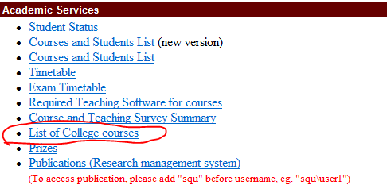

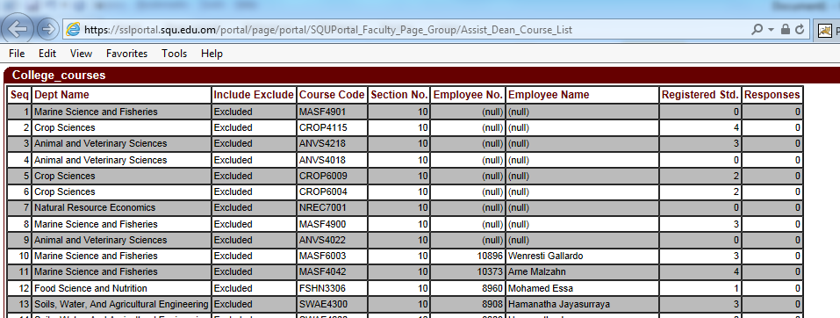

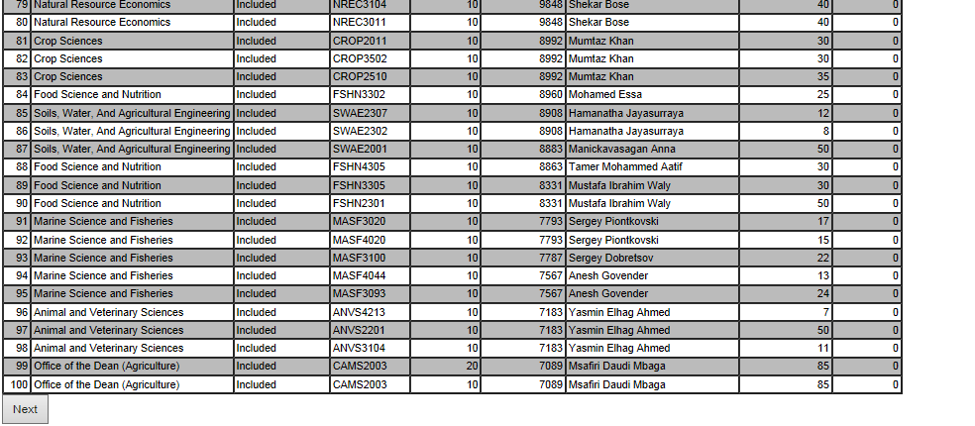

The query:

select row_number() over (order by decode(is_course_included_assistdean(c.course_code),'Y','Included','Excluded'), c.empno desc) as

seq,

c.crs_dept_name dept_name,

decode( clinical_course(c.course_code, c.crs_type_code),'Y','Clinical',

decode(is_course_included_assistdean(c.course_code),'Y','Included','Excluded')) Include_Exclude,

c.course_code,

c.sectno ,

c.empno,

f.emp_name,

c.seatstaken ,

get_std_responses(sem.l_abr_yrsem,c.course_code, c.sectno,c.empno,null,null) std_responses

from v_course_details@sis_link.squ.edu.om c,

v_faculty_portal@sis_link.squ.edu.om f,

v_current_yrsem_portal@sis_link.squ.edu.om sem

where c.empno = f.empno(+)

and course_code not like '%BOOK%'

and IS_ASSISTANT_DEAN(to_number(GET_EMP_NO))= 'Y'

and crs_col_code = assistant_dean_col(to_number(GET_EMP_NO))